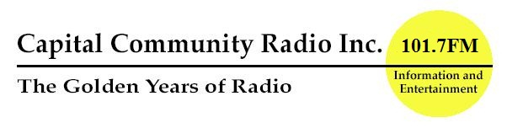
PO Box 1388  BOORAGOON, WA, 6954 | P.O. Box 1388  Booragoon, W.A. 6954
Tel: (08) 9364 9888
Fax: (08) 9364 1155
Web: www.capitalcommunityradio.com
Email: info@capitalcommunityradio.com

Volunteer Application Form
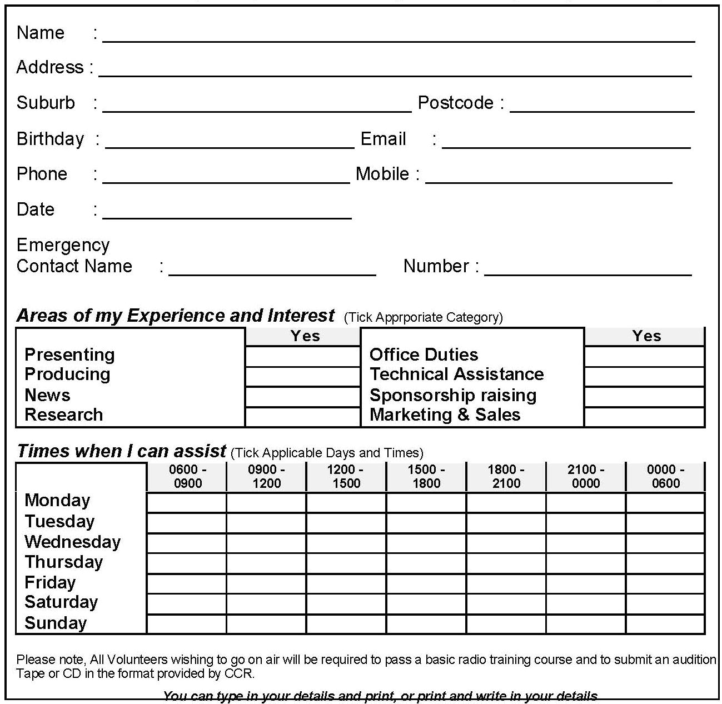
(All Information submitted treated in strict confidence)
Capital Community Radio Inc. (CCR) invites volunteers and appreciates their valuable time. If you would like participate in the day to day running of CCR, complete the details below. The fee to be paid is $20.00 annually, covering your insurance at our station (which is entirely run by volunteers)
PLEASE SIGN THE DECLARATION OVERLEAF
Then email, fax or post form and fee to: “The Volunteer Coordinator” at the above address.
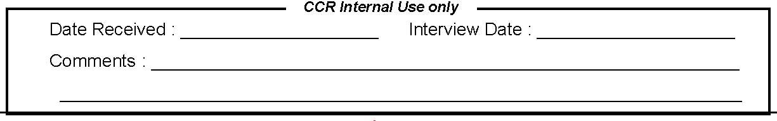
Volunteer Application Form

Declaration by Applicant

I understand and agree to abide by the Policy on Procedures, Rules and Standards as stipulated by Capital Community Radio and the CBAA radio Code of Practice when performing duties for and on behalf of Capital Community Radio.

Further, I will uphold the responsibilities and obligations as determined in the Capital Community Radio Constitution, Policies and Procedures, and the CBAA radio Code of Practice.

If I cease to be a volunteer of Capital Community Radio, I cannot claim a refund of my fee paid. I further agree to NOT copy, sell or pass Capital Community Radio intellectual property, which includes all publications, procedures, policies and other property, without written consent from the Capital Community Radio Management Committee.

I understand that failure to comply with the above may lead to expulsion from my role with Capital Community Radio.

Signed:_________________________________________ Date:______________________________

Witnessed:______________________________________ Position:___________________________

